|  |
| --- |
| **Argentis Consulting** |
| **Apparel & Footwear** |
| CUT TICKET GENERATION WIZARD |



**www.sapapparel.com**

# Cut Ticket Generation Wizard

This wizard allows users to create cut tickets based on orders. As an example, the user runs the wizard to

1. Consolidate styles with the same routing (cutting, sewing etc.)
2. Automate the order creation from different customer ship to addresses

To run the process, go to Production → Cut Ticket Generation Wizard

Select the orders to transfer to cut tickets

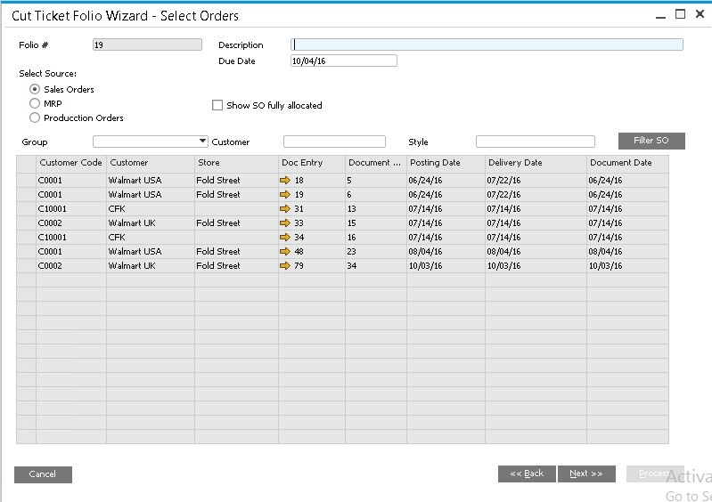

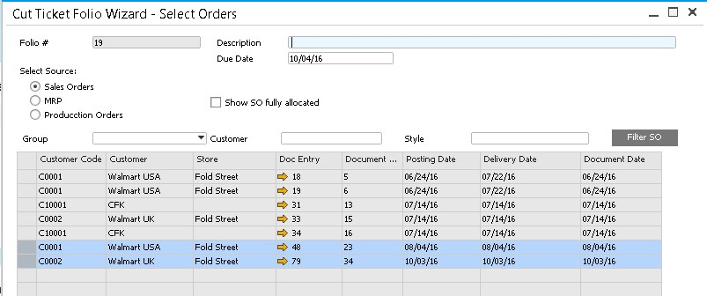

Select the lines in the order and click next

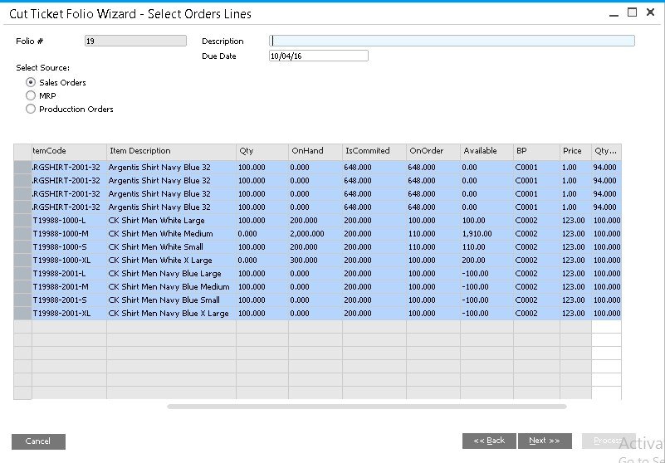

The wizard show the recommended cut tickets based on style production routing. There is also an option to consolidate if the style SKU repeats in the same or different order lines selected. In this example in the order 48 the same item shows in all lines.

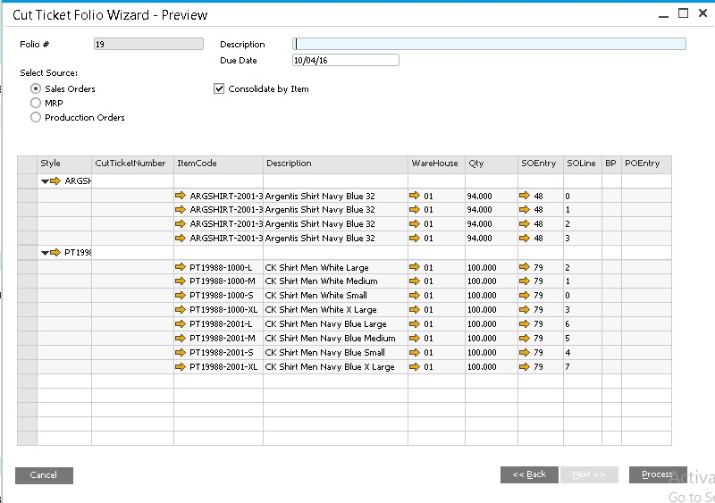

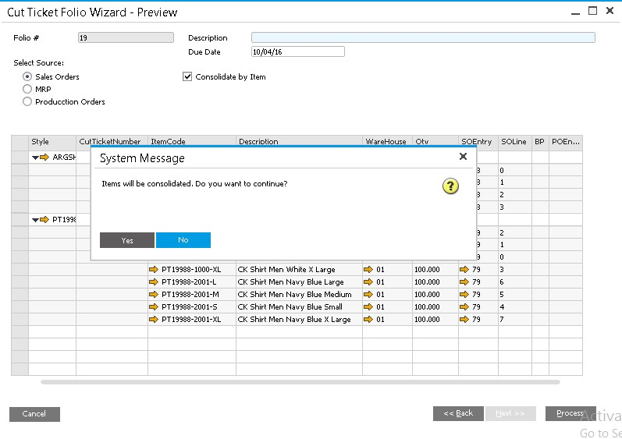

The wizard generates the cut tickets. The first cut ticket consolidates all items in one line.

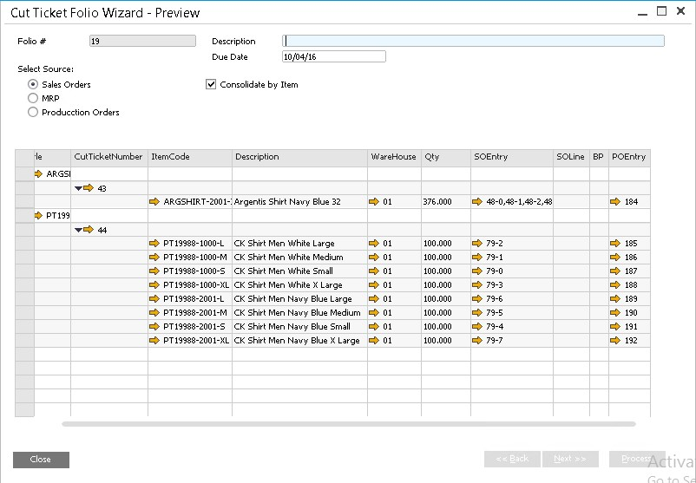

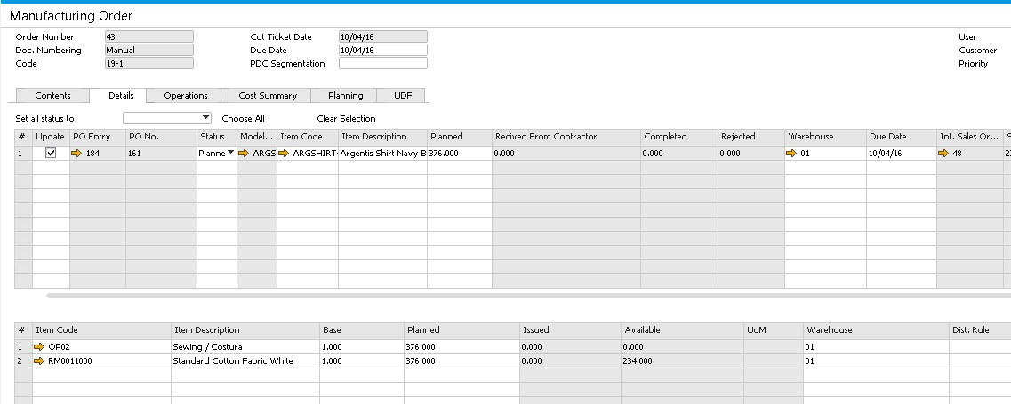



**www.argentisconsulting.com**

**Argentis Consulting** is dedicated to the development, distribution and support of recognized certified solutions for SAP Business One, as an SSP (Software Solution Provider) with a Gold Partner status.

**CONTACT INFORMATION**

|  |  |
| --- | --- |
| **USA**  9744 NW 45th Lane  Doral, FL 33178  info@argentisconsulting.com | **ARGENTINA**  Ávila y Zarate 2048  Cerro de la Rosas, Córdoba,  CP 5009  Córdoba - Argentina  info@argentisconsulting.com |
| **CARIBEAN**  City View Plaza – Suite 301  48 Road 165  Guaynabo, PR. 00968  Puerto Rico  caribe@argentisconsulting.com | **SPAIN**  C/ Juan Bravo N° 3 A 28006  Phone: (+34) 91 123 7263  Madrid - Spain  info@argentisconsulting.com |